THEMENBLOCK 17: Values & Attitudes in Society
CATEGORY A: CONTRASTING IMAGES
TASK SET A1: Small Kindness vs. Grand Charity

PART 1 — Individual Long Turn
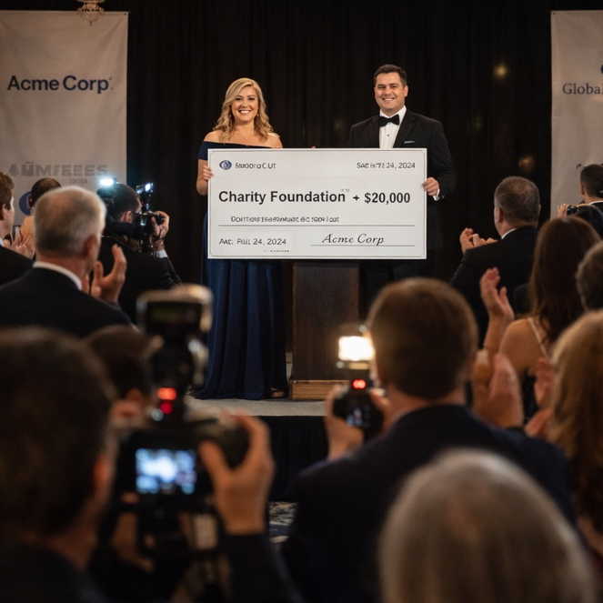
Task:
Give a five-minute talk on kindness and charity in which you
- Describe, compare and contrast the pictures above.
- Analyze which form of kindness has greater impact on individuals and society.
- Comment on your own experiences with giving or receiving kindness.

PART 2 — Paired Activity
Task:
Your class is creating a school-wide "Kindness Campaign" to encourage everyday helpful behaviour. Discuss and agree on THREE main elements to include:
- A "Random Acts of Kindness" challenge with suggested daily actions
- A recognition wall where students can anonymously thank someone who helped them
- A buddy system pairing older and younger students for support
- Workshop sessions on emotional intelligence and empathy
- A community service day connecting the school with local charities

TASK SET A2: Performative vs. Genuine Helping

PART 1 — Individual Long Turn
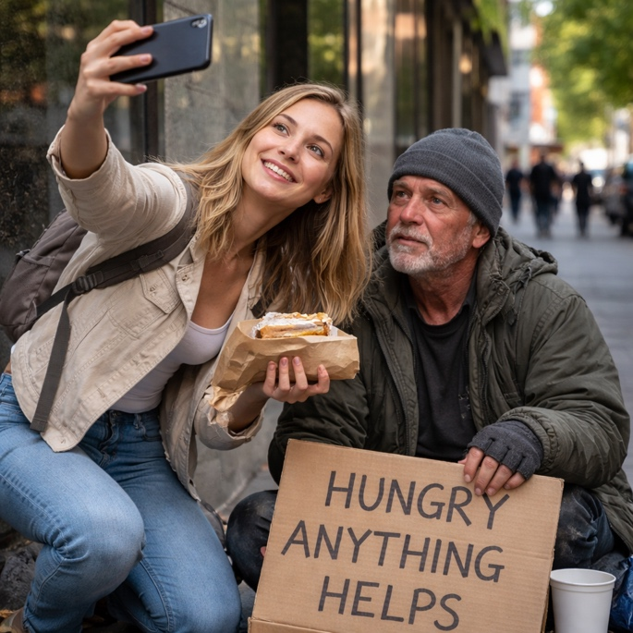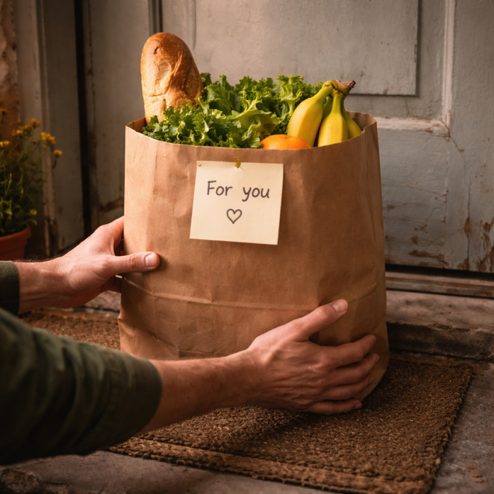

Task:
Give a five-minute talk on authenticity in helping others in which you
- Describe, compare and contrast the pictures above.
- Evaluate whether the motivation behind helping matters if the outcome is positive.
- Discuss how social media has changed the way people express and perceive charitable behaviour.

PART 2 — Paired Activity
Task:
Your student council is debating whether to encourage students to post about their volunteer work on social media. Discuss the following questions and agree on THREE to address:
- Does sharing volunteer work inspire others or just boost the sharer's image?
- How can we ensure that documenting charity respects recipients' dignity?
- Should schools require volunteer hours to be verified but kept private?
- What's the difference between raising awareness and virtue signaling?
- Can "influencer philanthropy" genuinely change culture or does it trivialize giving?

TASK SET A3: Apathy vs. Active Community Engagement

PART 1 — Individual Long Turn
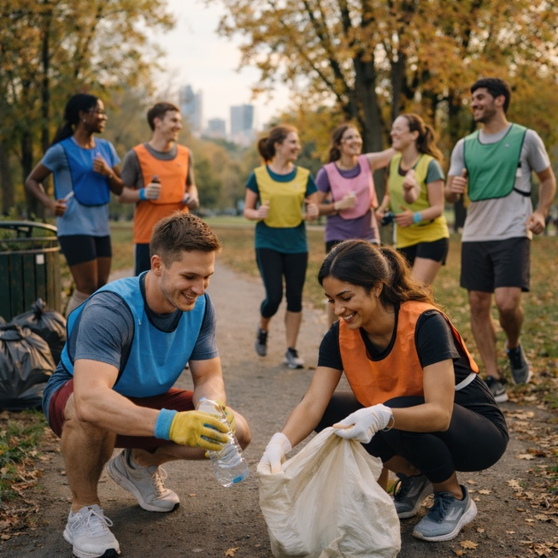
Task:
Give a five-minute talk on community engagement and environmental responsibility in which you
- Describe, compare and contrast the pictures above.
- Analyze why people often ignore problems in public spaces even when solutions are simple.
- Discuss what could make such simple social-civic activities more appealing to young people.

PART 2 — Paired Activity
Task:
Your town council wants to launch a youth-led environmental initiative and has asked for student input. Discuss and agree on THREE elements to include in the program:
- The format: regular plogging meetups, one-off seasonal cleanup events, or an ongoing "adopt a spot" scheme where groups take responsibility for specific areas?
- How to make participation social and genuinely fun rather than feeling like a chore or obligation
- Whether to use social media to promote the initiative (before/after photos, challenges, leaderboards) and the pros and cons of this approach
- What incentives, if any, to offer — certificates, small prizes, recognition, or simply the social experience itself
- How to ensure the initiative is inclusive and welcoming to people of all fitness levels and backgrounds

CATEGORY B: QUOTES
TASK SET B1: The Value of Small Kindness

PART 1 — Individual Long Turn
Quote 1:
"No act of kindness, no matter how small, is ever wasted."
— Aesop, "The Lion and the Mouse" (Aesop's Fables)
Quote 2:
"How wonderful it is that nobody need wait a single moment before starting to improve the world."
— Anne Frank, Anne Frank's Tales from the Secret Annex
Task:
Give a five-minute talk on making a difference through small actions in which you
- Analyze and compare the two quotes above, explaining what each author means.
- Discuss why small acts might matter more than grand gestures in building a better society.
- Comment on a time when a small kindness made a significant impact in your life.

PART 2 — Paired Activity

Task:
You are working with a volunteer coordinator to design a community service project. Discuss and agree on THREE priorities:
- Whether to focus on a single large project or multiple small ongoing actions
- How to ensure the project benefits recipients rather than just making volunteers feel good
- Ways to measure the impact of your service beyond counting volunteer hours
- How to involve students who are reluctant or skeptical about volunteering
- Whether to partner with existing organizations or create something independent

TASK SET B2: Authenticity in a Conformist World

PART 1 — Individual Long Turn
Quote 1:
"To be nobody-but-yourself — in a world which is doing its best, night and day, to make you everybody else — means to fight the hardest battle which any human being can fight; and never stop fighting."
— e.e. cummings, "A Poet's Advice to Students," Spectator (1955)
Quote 2:
"Authenticity is a collection of choices that we have to make every day. It's about the choice to show up and be real. The choice to be honest. The choice to let our true selves be seen."
— Brené Brown, The Gifts of Imperfection (2010)
Task:
Give a five-minute talk on authenticity and conformity in which you
- Analyze and compare the two quotes above, explaining how each author views authenticity.
- Discuss the specific pressures young people face today that make being authentic difficult.
- Comment on whether authenticity requires constant "fighting" or can become natural over time.

PART 2 — Paired Activity
Task:
You have been invited to meet with your school psychologist to discuss creating resources about peer pressure and authenticity. Discuss and agree on THREE to focus on:
- How social media creates pressure to present a perfect or popular version of yourself
- The difference between healthy adaptation (code-switching) and losing your identity
- How to build confidence in expressing unpopular opinions or unusual interests
- The role of trusted adults and friends in supporting authentic self-expression
- Whether being "yourself" is possible when identity is constantly evolving

CATEGORY C: ALTERNATIVE PROMPTS
TASK SET C1: Gen Z Values — Authenticity Over Wealth

PART 1 — Individual Long Turn
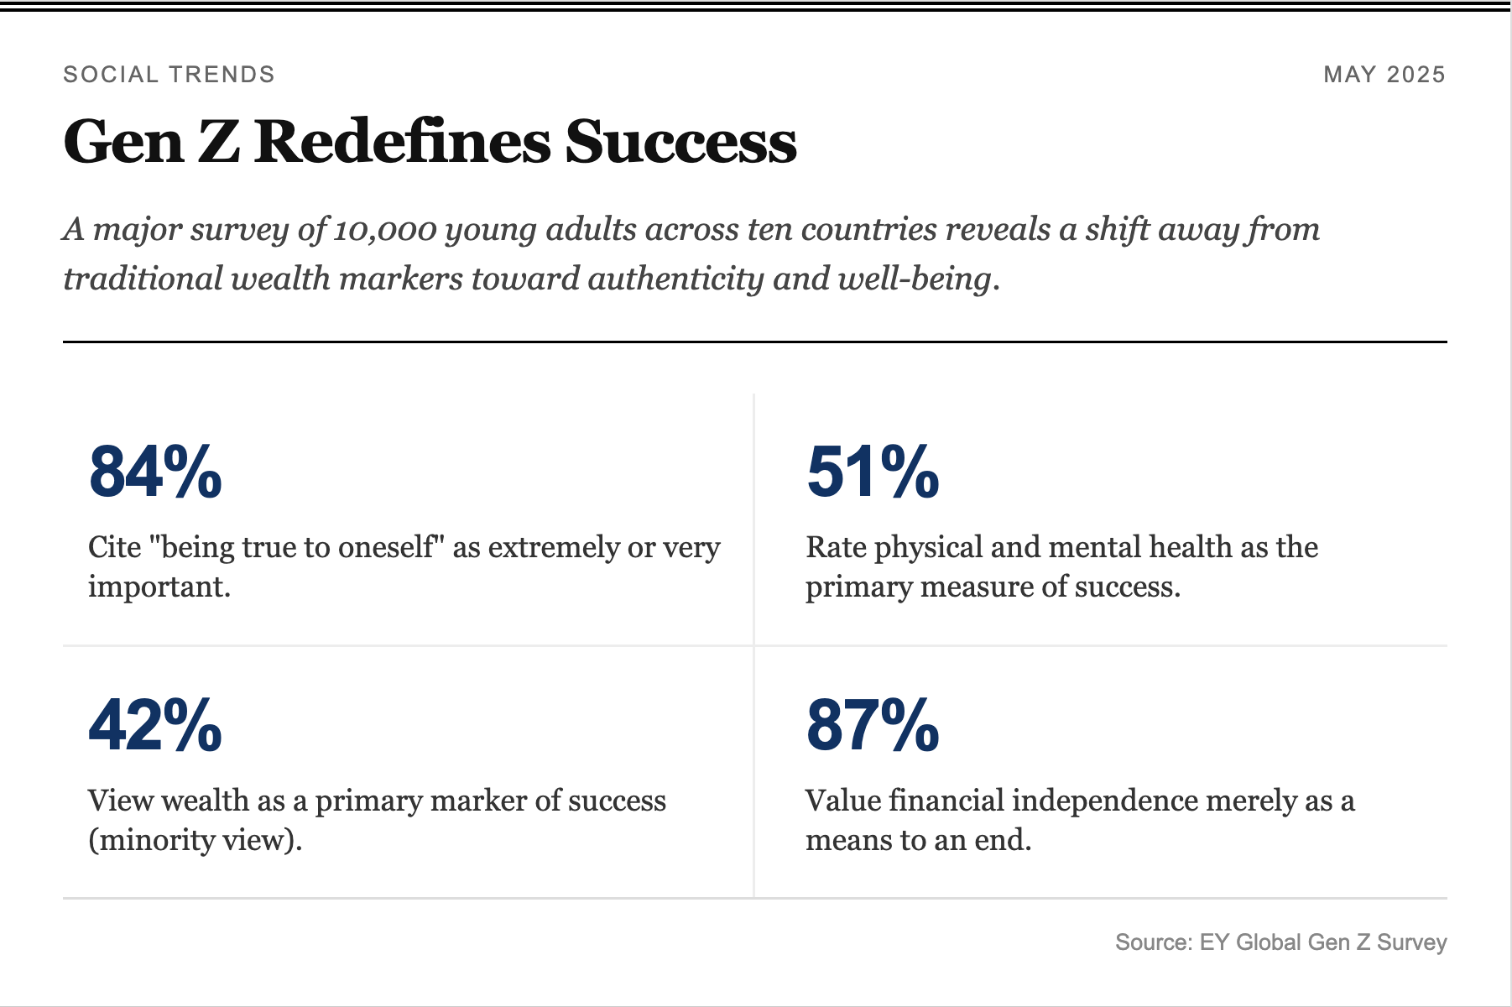
Task:
Give a five-minute talk on changing values across generations in which you
- Analyze the statistics presented and explain what they reveal about Gen Z priorities.
- Discuss possible reasons why authenticity has become more important than traditional markers of success.
- Comment on whether these priorities represent genuine progress or potential problems.

PART 2 — Paired Activity

Task:
Your school newspaper is running a feature on "What Success Means to Our Generation." Take opposing positions and discuss:
- Whether prioritizing authenticity over wealth is realistic in today's economy
- How parents' and grandparents' generations might view this value shift
- Whether these values will survive when Gen Z has mortgages and families
- The role of privilege in being able to choose authenticity over financial security
- Whether businesses and workplaces will adapt to these changing expectations

TASK SET C2: Youth Volunteering Trends

PART 1 — Individual Long Turn

YOUTH VOLUNTEERING: GLOBAL PATTERNS
Recent OECD research (December 2024) reveals patterns in volunteering:
- In France, 2024 volunteering rates for 15-34 year-olds exceeded 2010 levels
- The 2024 Paris Olympics received over 300,000 volunteer applications for 45,000 positions
- After the 2012 London Olympics, 66.2% of volunteers continued volunteering afterward
- Education correlates with volunteering: 25% tertiary-educated vs. 20% secondary-educated volunteer monthly
— OECD, "Unleashing the Potential of Volunteering," December 2024

Task:
Give a five-minute talk on volunteering and community engagement in which you
- Analyze what the data reveals about patterns and motivations in youth volunteering.
- Discuss the benefits and potential drawbacks of volunteering for young people.
- Comment on whether volunteering should be encouraged more strongly in schools.

PART 2 — Paired Activity

Task:
Your town is launching a youth volunteer program. Discuss and agree on THREE initiatives to recommend:
- An intergenerational program pairing young people with elderly residents
- Environmental projects like park cleanups or community gardens
- Tutoring and mentoring for younger students from disadvantaged backgrounds
- Digital skills workshops to help older adults navigate technology
- Event support for local cultural festivals and sports events

